UI/UX DESIGN
DocExtract - Intelligent Document Processing

Document Control
Document History
Version | Date | Author | Description
1.0 | 30 July 2026 | DocExtract Project Team | Initial document: design system, information architecture, user flows, page designs for 11 screens, component patterns, accessibility, and a record of design decisions.

Document Distribution
# of Copy | Description | Location
1 | Digital copy (.docx) | Project repository, Works/ folder
2 | Supporting image files | Works/screenshots/

Table of Contents
1. Purpose and Scope
2. Design Principles
3. Design System
4. Information Architecture and Access Rights
5. User Flows
6. Page Designs
7. Component Patterns
8. Accessibility
9. Responsive Design
10. Design Decision Record
11. UI/UX Design Approval

1. Purpose and Scope
This document records the interface and user-experience design of DocExtract: the visual token system in use, the navigation structure and what each role may reach, the main working flows, the design of each page, and the patterns that repeat across screens. Its purpose is that anyone adding a new page can follow the same rules without guessing.
Every token value in section 3 is taken directly from frontend/tailwind.config.js and frontend/src/index.css, and the access rules in section 4 are taken from frontend/src/App.tsx together with the role guards in backend/app/main.py. This document describes the application as it actually runs, not a design that was hoped for.
Out of scope: the database design (see document 5, Database Design), the business process (document 2, Business Process Document), and the test scenarios (document 3, Testing Scenario).
2. Design Principles
Five principles underpin every design decision in this application.
- The source document is always visible: On the review screen the original document image sits beside the extracted data. A reviewer is never asked to trust a number without being able to check it against its source.
- Safe by default: Extracted fields are locked when the page opens and become editable only after Correction is pressed. Irreversible actions are separated out and restricted by role.
- Problems are shown, not hidden: Every rule violation appears as a graded note, error or warning, naming the field and the figures involved, rather than a bare red mark.
- Numbers follow Indonesian conventions: All Rupiah values are shown with dots as thousands separators, right aligned in a monospace face so figures line up between rows.
- One task, one page: Each page answers a single question: what needs review, what has been signed off, how accurate the model is. The sidebar shows only the pages that role is allowed to open.
3. Design System
Tokens originate from the Stitch export and were ported to Tailwind. Token names are used directly in the code, so the tables below can be searched word for word inside the components.
3.1 Colour Palette
Colour carries meaning rather than decoration. Status colours are used only for status.
Token | Hex | Used for
primary | #002452 | Brand colour on the logo and application title
secondary | #0051D5 | Primary actions, links, and the active navigation item
secondary-container | #316BF3 | Badge backgrounds and count markers
text-primary | #1A2433 | Body text
on-surface-variant | #44474F | Secondary text, labels and captions
surface / background | #F7F9FC | Page background
surface-white | #FFFFFF | Card, table and panel backgrounds
surface-container-low | #F2F4F7 | Alternating table rows
border-base | #E3E8EF | Borders on cards, tables and input fields
status-success | #15803D | Approved status
status-review | #1D4ED8 | In-review status
status-warning | #B45309 | Validation warnings and flagged status
status-error | #B91C1C | Validation errors and rejected status
status-neutral | #64748B | Extracted status and neutral states

3.2 Typography
One type family across the interface (Inter), plus one monospace face for figures. The scale below is fixed; sizes outside this list are not used.
Token | Size / Line height | Weight | Used for
display | 30 / 38 px | 700 | Large figures on metric cards
headline-lg | 24 / 32 px | 600 | Page titles
headline-md | 20 / 28 px | 600 | Card and section titles
body-lg | 16 / 24 px | 400 | Introductory paragraphs
body-md | 14 / 20 px | 400 | Body text and table cells
body-sm | 13 / 18 px | 400 | Supporting text and filter controls
label-md | 12 / 16 px | 600 | Field labels
label-sm | 11 / 14 px | 600 | Table column headers and badges
mono-data | 13 / 20 px | 450 | Document numbers and Rupiah values (JetBrains Mono)

3.3 Layout, Spacing and Radius
Token | Value | Used for
sidebar-width | 260 px | Width of the expanded sidebar
topbar-height | 64 px | Height of the top bar
gutter | 24 px | Spacing between cards and page padding
stack-sm / md / lg | 8 / 16 / 24 px | Vertical spacing between elements
rounded (default) | 0.25 rem | Corners on small elements
rounded-lg | 0.5 rem | Corners on cards, buttons and inputs
rounded-xl | 0.75 rem | Corners on large panels
rounded-full | 9999 px | Badges and the active navigation pill
max-w-6xl | 72 rem | Maximum width of the content area

3.4 Iconography
The application uses a single icon set, Material Symbols Outlined, loaded as an icon font. Icons always sit next to text unless the control already carries an aria label. Icon size follows the adjacent text size: text-base for controls, text-lg for card headings.
3.5 Motion
Animation is used to explain change, not to entertain. Only three animations exist.
Name | Duration | Used for
fade-in | 0.3 s ease-out | Elements that appear without moving
fade-slide-up | 0.4 s ease-out | Cards and rows entering, with a staggered delay
pulse-soft | 2 s, repeating | Marking work that is currently running

All animation is disabled automatically for users who have enabled the prefers-reduced-motion setting in their operating system (frontend/src/index.css line 49).

4. Information Architecture and Access Rights
The sidebar shows only the pages the signed-in role may open. If an address is typed directly, the role guard in the interface shows a No access screen and the guard on the server refuses the data request. The two are independent, so hiding a menu item is never the only protection.
Page | Route | user | staff | admin
Upload | /upload | Yes | Yes | Yes
Review Queue | /review | No | Yes | Yes
Document detail | /review/:id | Own only | Yes | Yes
Dashboard | /dashboard | No | Yes | Yes
Archive | /archive | No | Yes | Yes
Archive by month | /archive/:year/:month | No | Yes | Yes
Assistant | /chat | Yes | Yes | Yes
Audit Log | /audit | No | No | Yes
Model Speed | /performance | No | No | Yes
Settings | /admin/settings | No | No | Yes

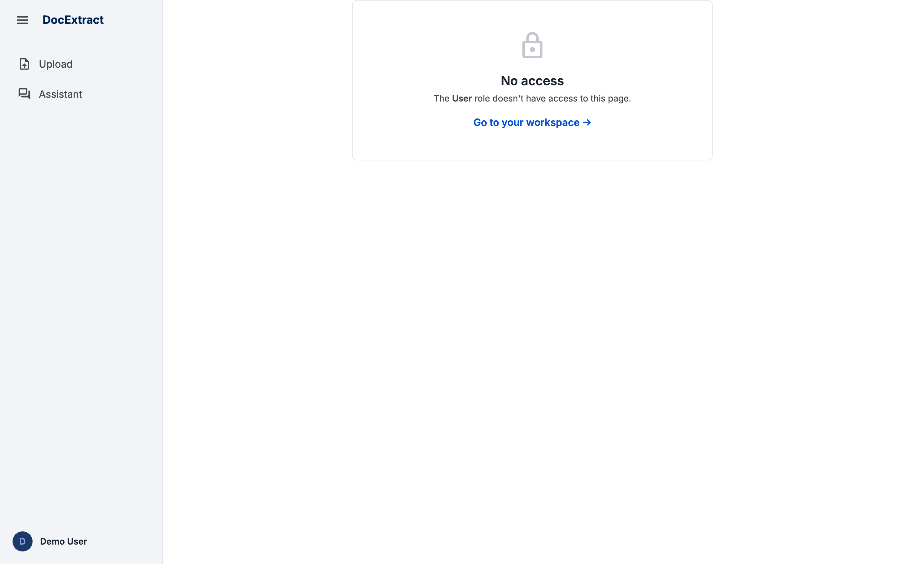
Figure 1 - The No access screen when a user role opens a page it may not reach

5. User Flows
The three flows below cover a document's entire journey through the system.
5.1 The user role: upload and view results
Step | Activity
1 | Sign in with a user-role account.
2 | Open the Upload page and drop one or more files.
3 | Set the type of each document and choose the extraction model.
4 | Press Extract and wait for the run to finish.
5 | Read the extracted results beside the source document.
6 | Track the status of their own documents in the list below.

5.2 The staff role: review and correct
Step | Activity
1 | Sign in with a staff-role account.
2 | Open the Review Queue and filter for flagged documents.
3 | Open one document; the fields are still locked.
4 | Press Correction to unlock the fields.
5 | Fix the wrong fields; validation re-runs immediately.
6 | Press Save Correction; the fields lock again.
7 | Leave the final decision to an admin. Staff have no Approve or Reject button.

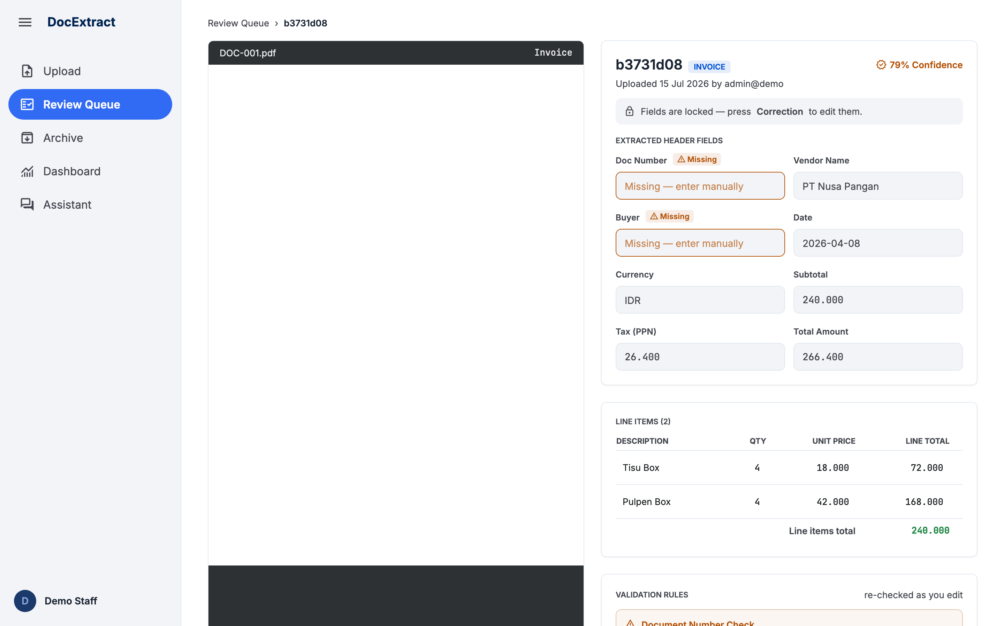
Figure 2 - The staff review screen: fields locked, missing fields marked, no approval controls

5.3 The admin role: approve, archive, export
Step | Activity
1 | Sign in with an admin-role account.
2 | Open a corrected document from the Review Queue.
3 | Press Approve & Export. The system stamps the approval time and posts the data to the downstream API.
4 | The document moves into the Archive under its approval date.
5 | Open the Archive, pick the year, then open the month required.
6 | Press Export and choose the period and file format.
7 | The file downloads; the export is recorded in the Audit Log.

6. Page Designs
6.1 Sign In
Provides a single entry point for all three roles.
- A single fixed-width card centred on screen.
- Three demo-account tabs that fill in the credentials automatically.
- Email and password fields, and a Sign in button.
- Failure state: a short message, the user stays on the page, no session created.
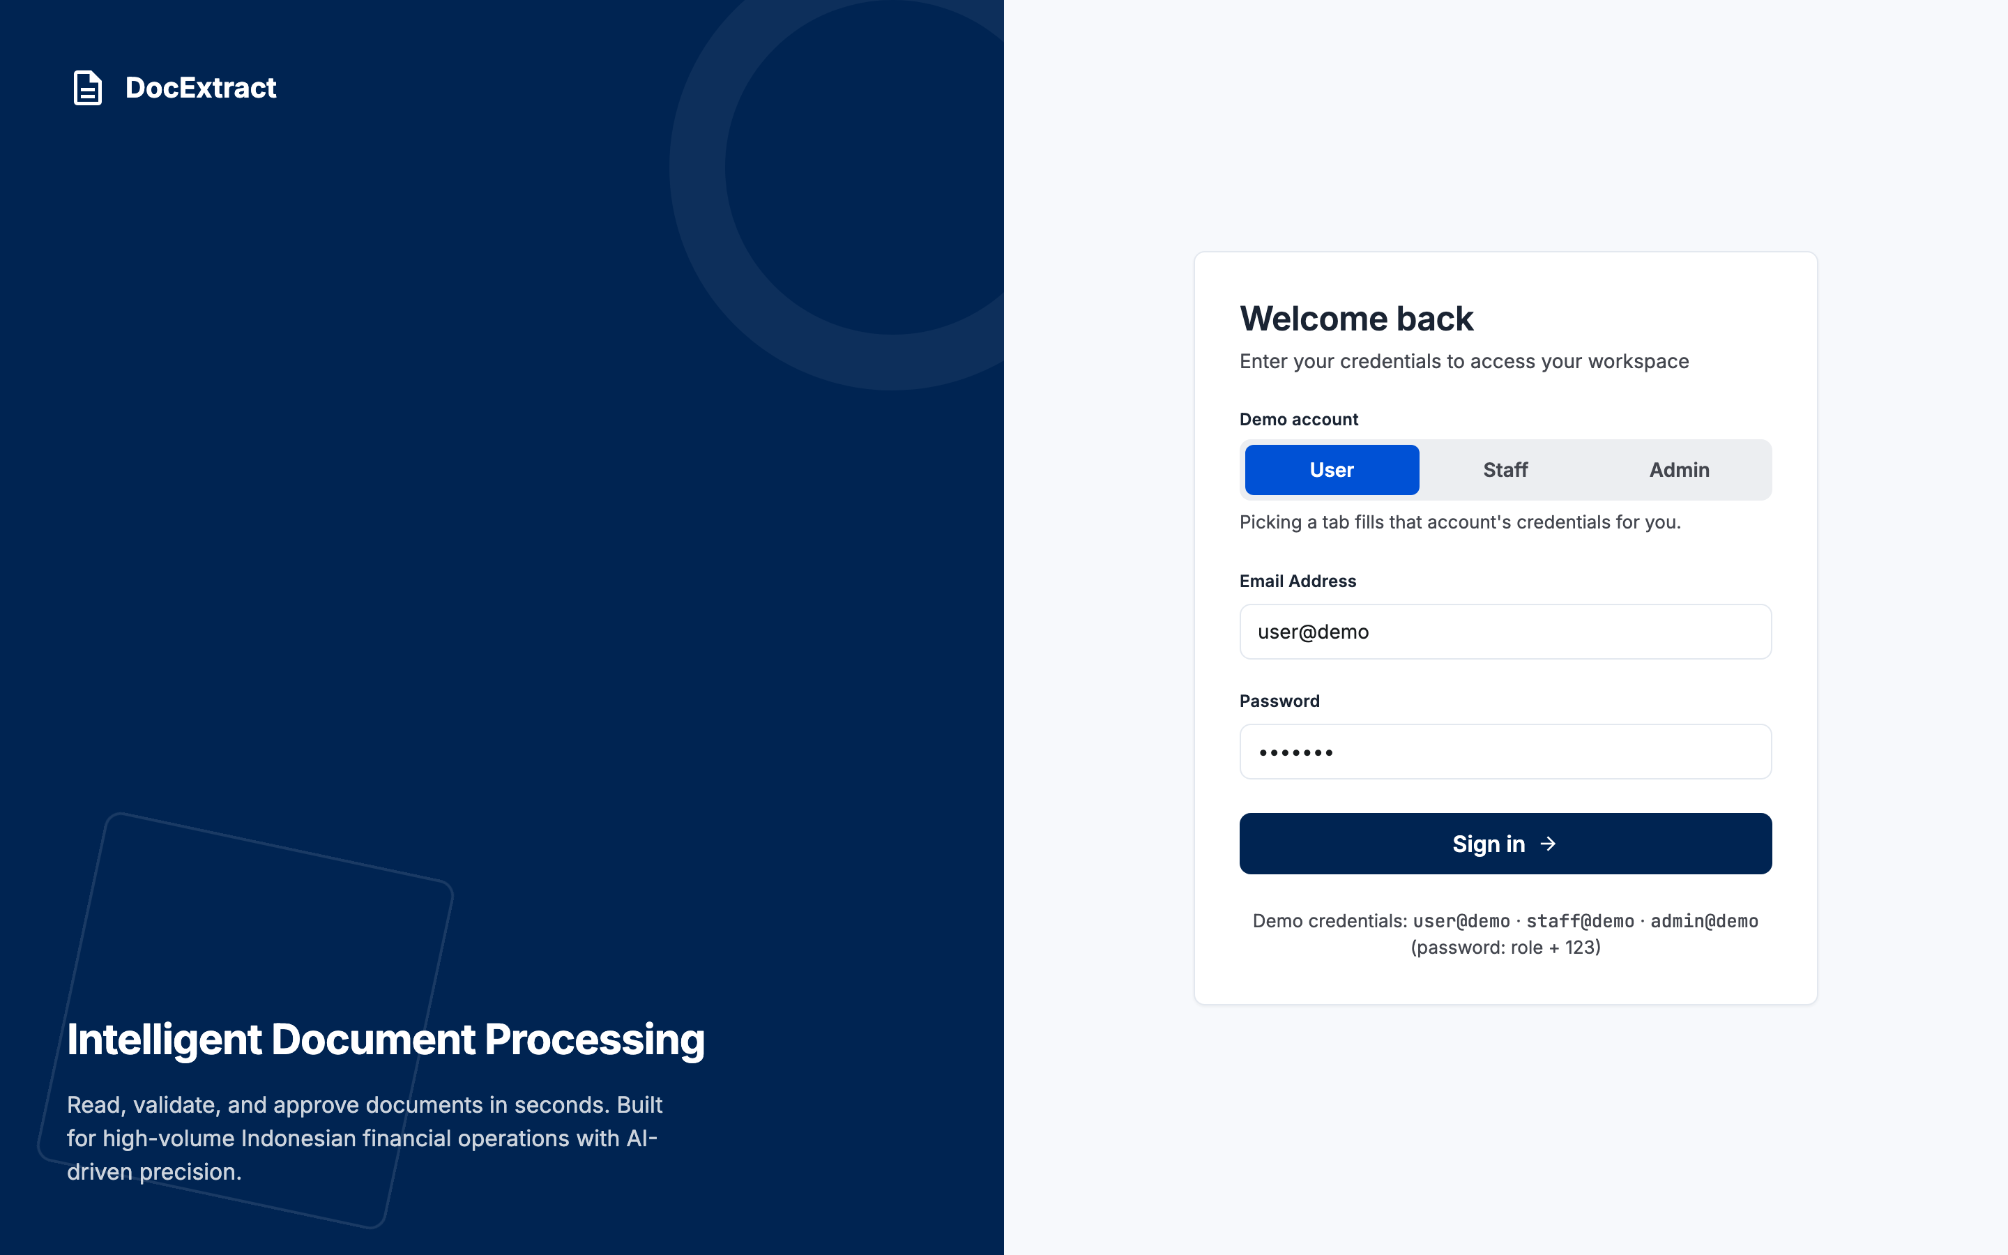
Figure 3 - The Sign In page

6.2 Upload
The point where documents enter; the only page every role can use to add data.
- A drag-and-drop area accepting PDF and image files.
- A list of staged files, each row with its own document-type selector and a remove button.
- An extraction-model picker; unconfigured models appear disabled with the reason shown.
- All controls are disabled while an extraction is running.
- Below it, a list of the user's own documents and their statuses.
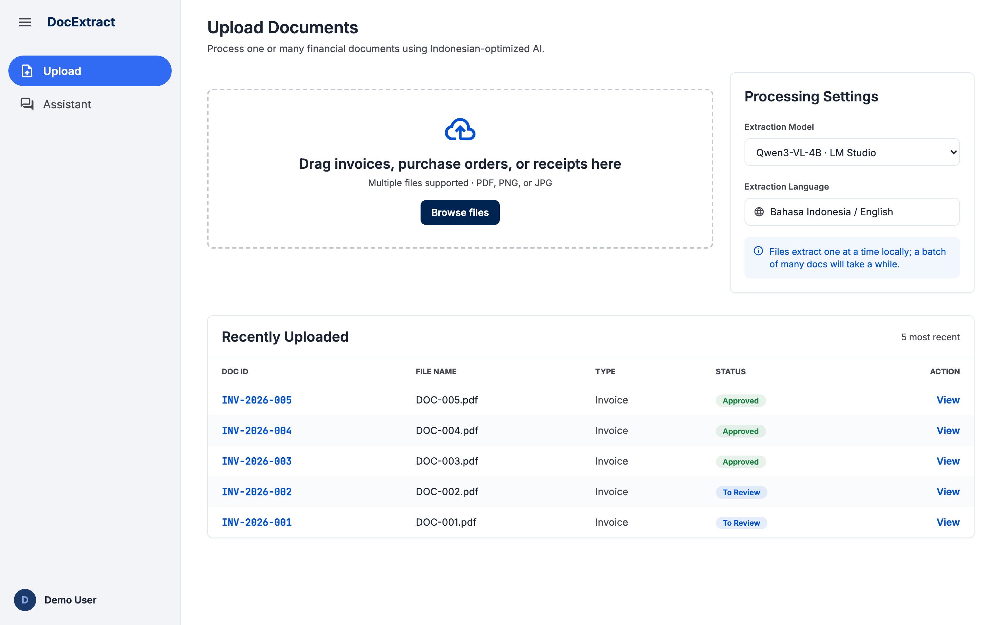
Figure 4 - The Upload page

6.3 Review Queue
The worklist for the staff and admin roles.
- Filter bar: keyword, date range, uploader, type and status.
- A Clear button that resets every filter at once.
- A table showing ten rows per page; changing a filter returns to page one.
- Checkboxes are active only on approved rows, because only those may be exported.
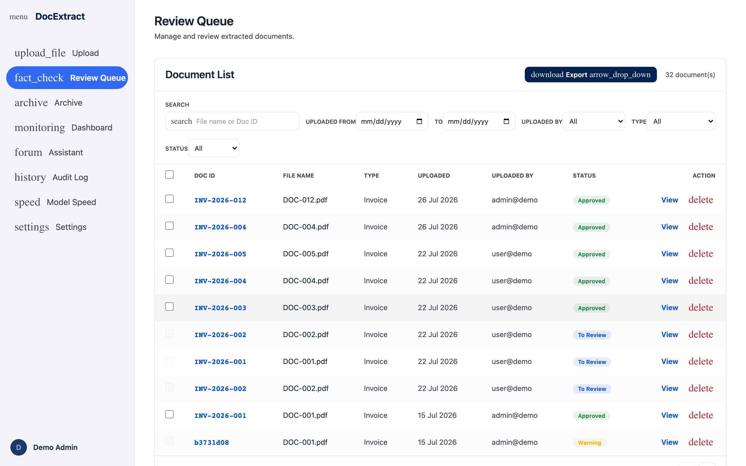
Figure 5 - The Review Queue with filters and pagination

6.4 Document Detail and Review
The screen where a human actually decides.
- Two columns: the source document on the left, extracted data on the right.
- Fields are locked on opening, with a note explaining how to unlock them.
- Empty fields carry a Missing badge and a coloured border.
- A line-item table with a total on the closing row.
- A validation panel that re-runs every time a value changes.
- Decision buttons appear only for the admin role.
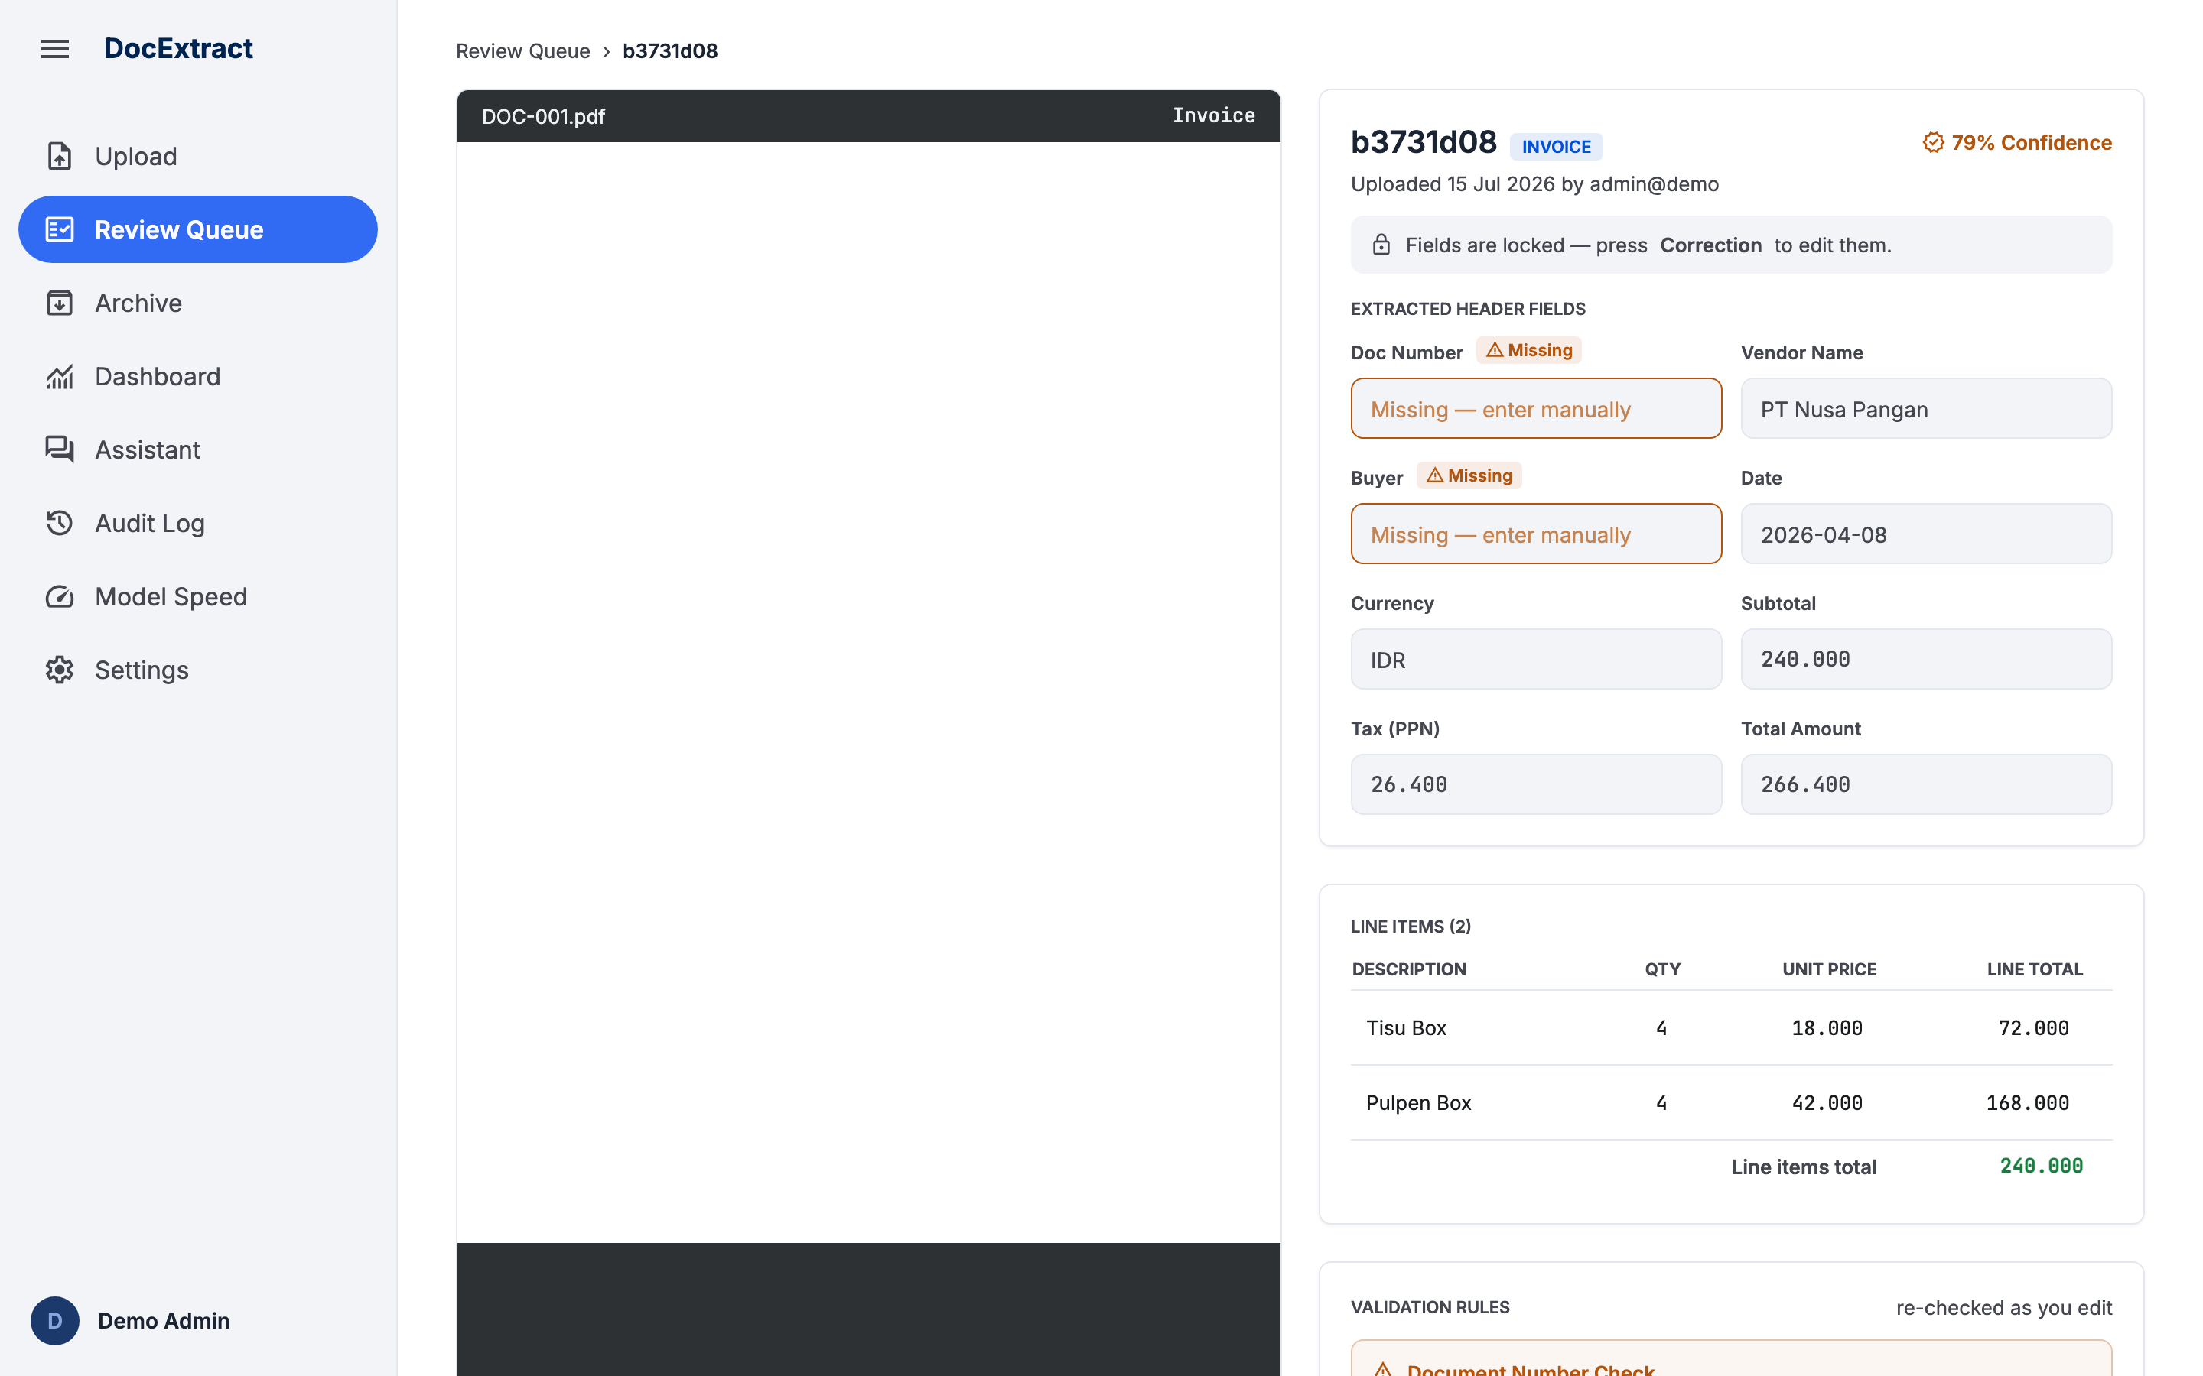
Figure 6 - The admin review screen, with the decision controls

6.5 Archive
The formal record of approved documents, filed by approval date.
- A year bar whose forward and back arrows are disabled outside the range of years that hold data.
- A grid of twelve months; months without documents appear disabled.
- An Export button beside the year.
- The month page groups documents by approval date, each group collapsible.
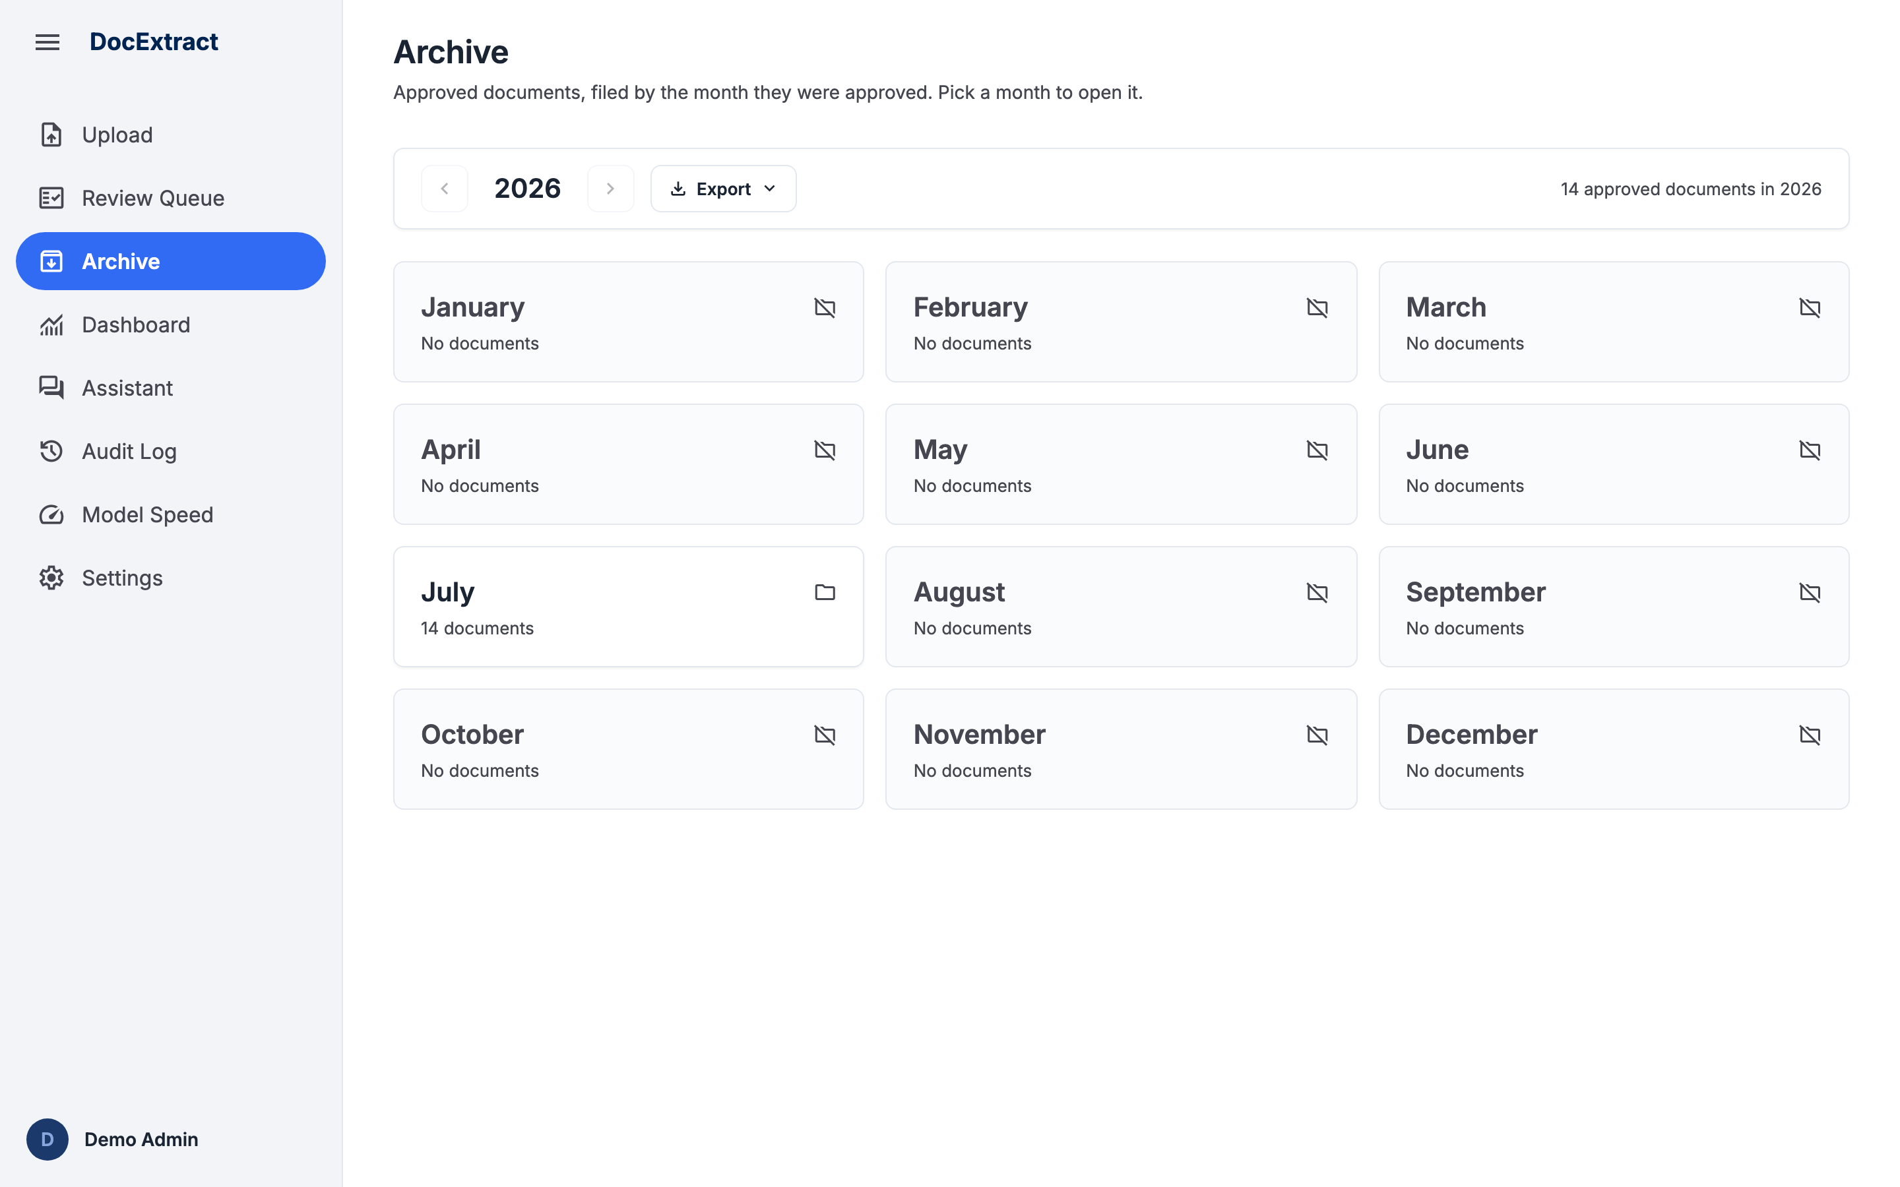
Figure 7 - The Archive, one-year view

6.6 Archive Range Export
Turns the archive into a report file without forcing the user to download documents one at a time.
- The popup is anchored below the button, capped to the viewport height and scrollable.
- Period choice: a full year, a range of months, or a range of dates.
- A document-type filter.
- Five file formats, each with a short note on what it contains.
- A pinned footer showing how many documents will be exported, and the Export button.
- Empty state: the count drops to zero and Export is disabled.
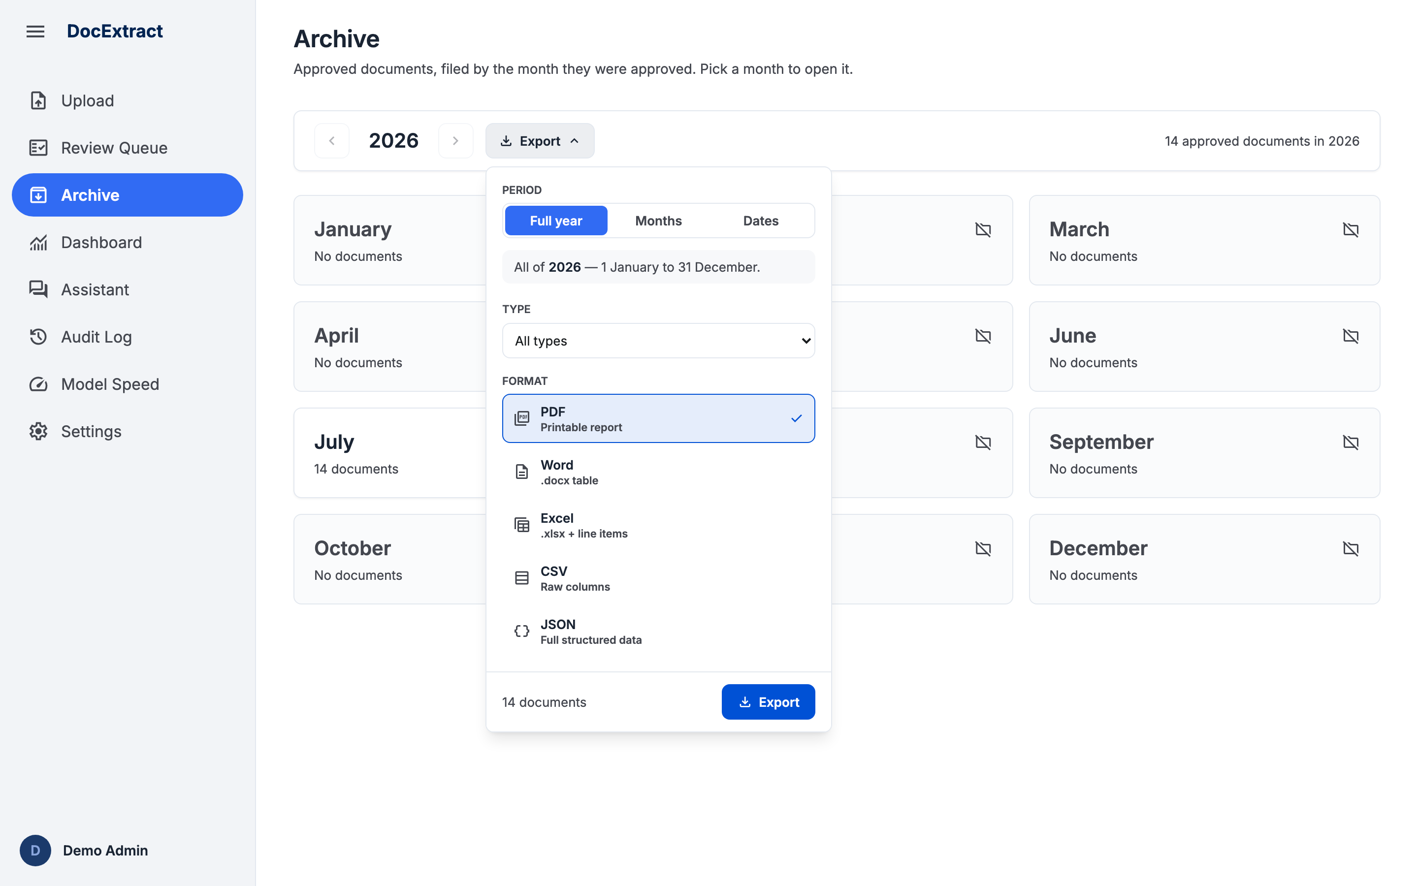
Figure 8 - The Archive range export popup

6.7 Dashboard
Answers three questions at once: how many documents, how accurate the model is, and how much it saves.
- Four metric cards: total, pending review, approved and flagged.
- An accuracy panel measured against the ground truth, with a button to run the evaluation.
- While an evaluation runs, its progress updates every three seconds.
- Document spread by type, and the most frequently broken validation rules.
- An ROI calculator with every assumption editable in place.
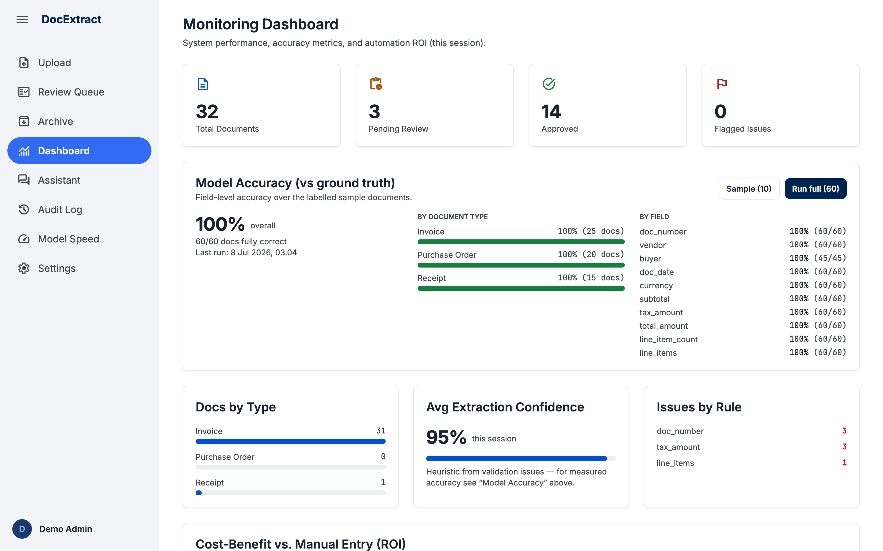
Figure 9 - The Monitoring Dashboard

6.8 Audit Log
The accountability trail: who did what, and when.
- A table of timestamp, actor, role, action type and detail.
- Newest entries first.
- Reachable by the admin role only.
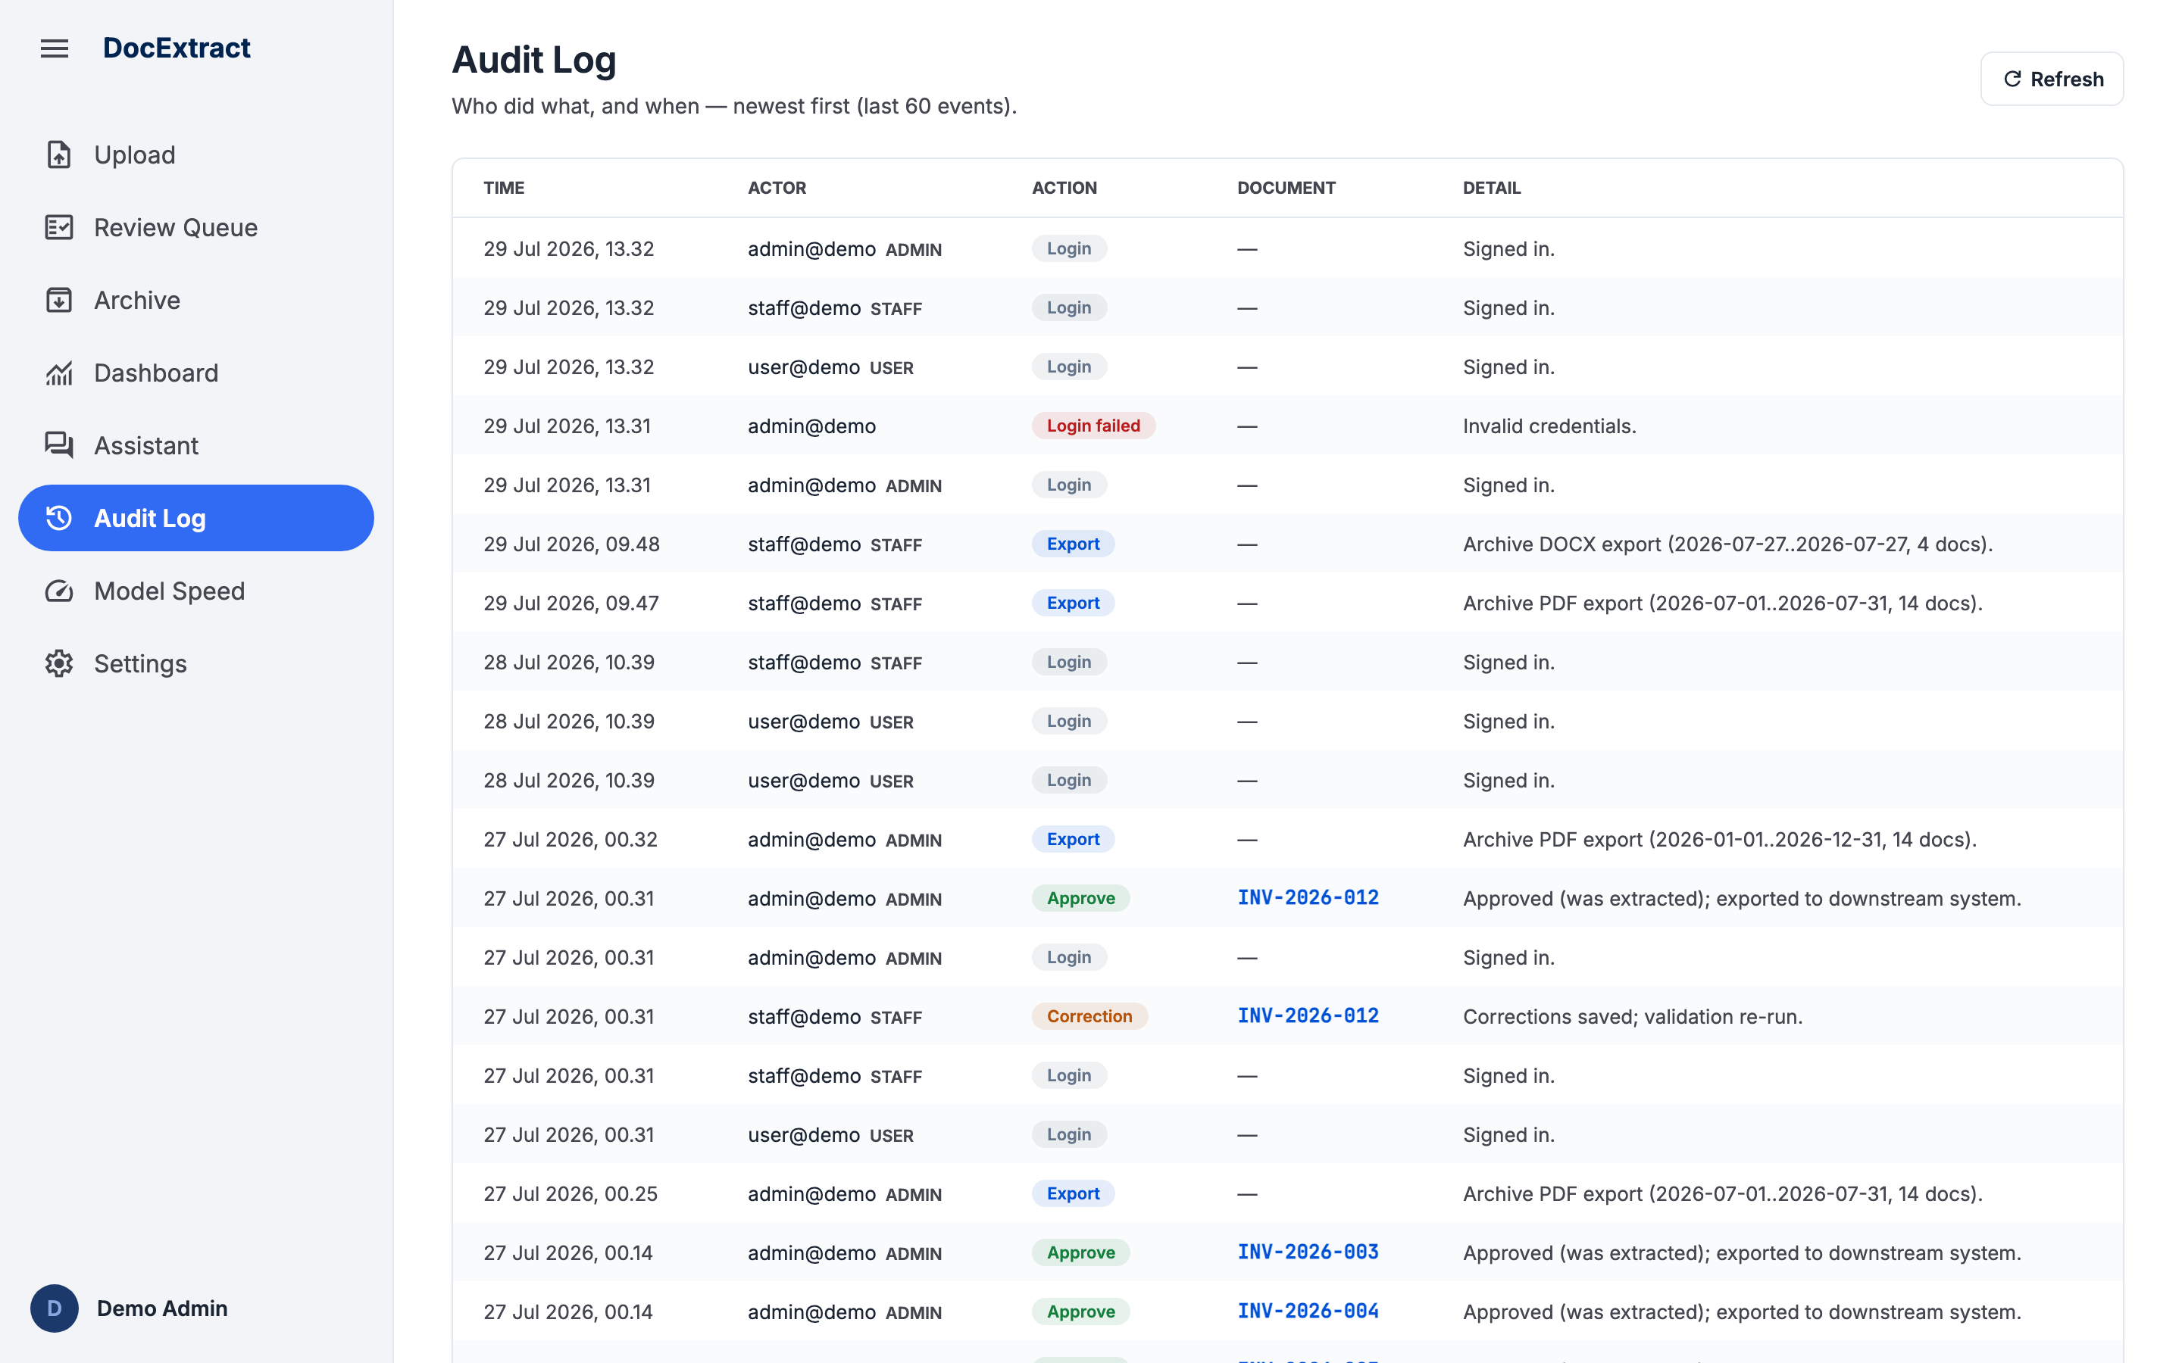
Figure 10 - The Audit Log

6.9 Settings
Tunes the business rules without touching code.
- Validation thresholds: PPN rate, reconcile tolerance and the low-confidence threshold.
- User management: adding and removing accounts and their roles.
- The signed-in account cannot be deleted.
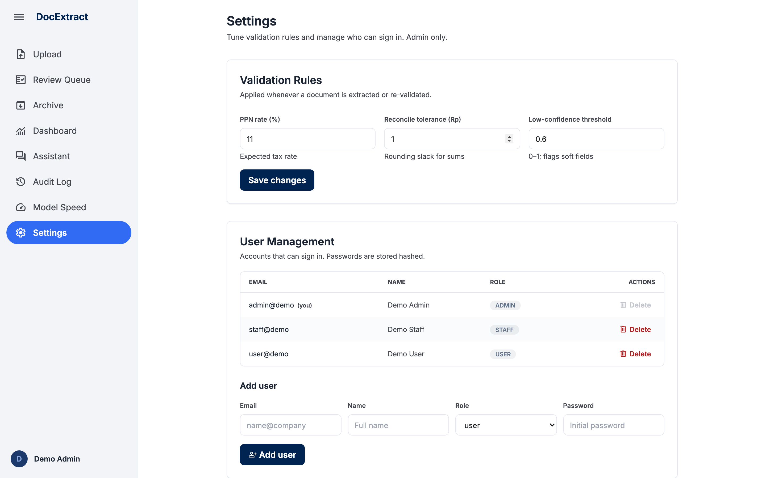
Figure 11 - Settings

6.10 Model Speed
Shows where extraction time goes.
- A breakdown of processing time per model.
- Helps spot documents that are unusually slow.
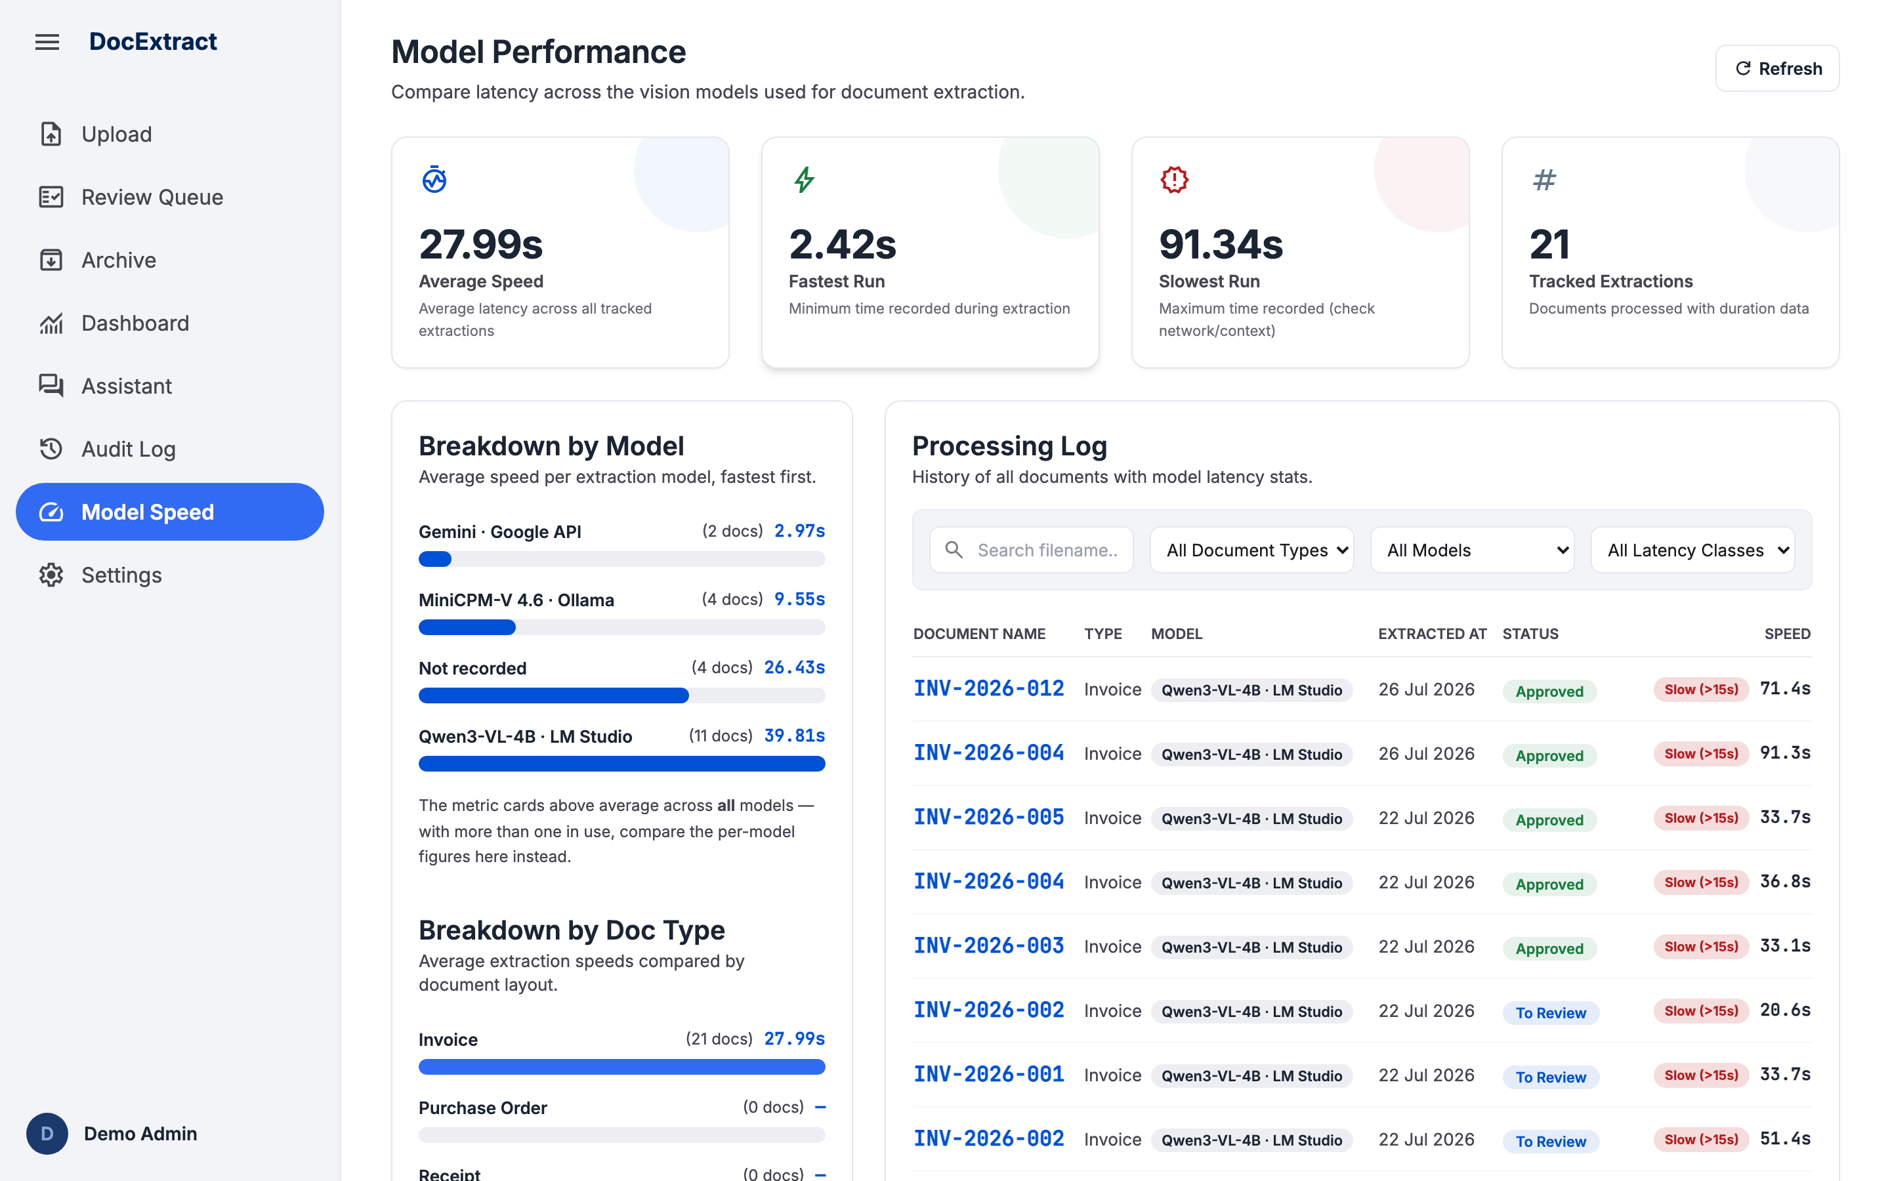
Figure 12 - The Model Speed page

6.11 Assistant
A bonus feature: asking questions about the extracted documents.
- A list of chat sessions on the left, with titles generated automatically.
- A question can be scoped to a single document.
- Answers cite the documents they came from.
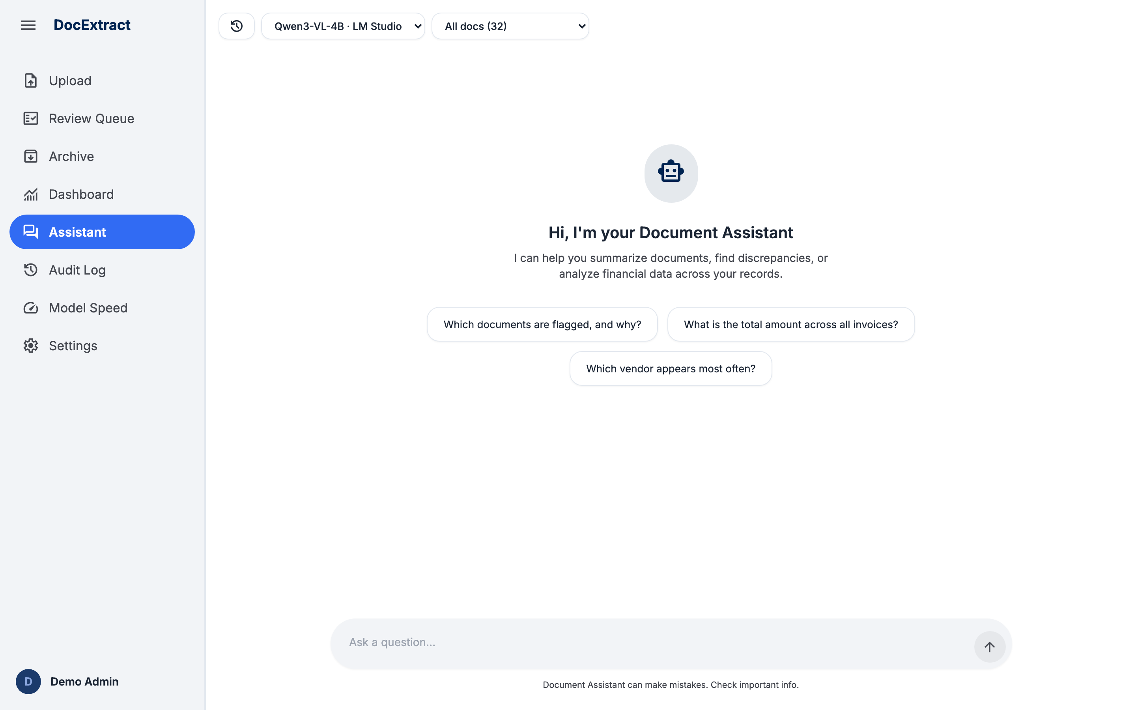
Figure 13 - The Document Assistant

7. Component Patterns
The patterns below recur across several pages. A new page should reuse an existing pattern rather than inventing a variant.
Pattern | Rule
Status badge | Pill shaped, coloured by status token, with the status always spelled out. Colour is never the only signal.
Data table | Column headers use label-sm in capitals. Alternating rows use surface-container-low. Figures are right aligned in a monospace face. A wide table scrolls inside its own container rather than scrolling the page.
Filter bar | Sits inside the card, above the data it filters. The Clear button appears only while a filter is active.
Popup menu | Anchored to its trigger, dismissed by clicking outside or pressing Escape. Height is capped to the viewport and the action footer stays visible.
Toast | Appears in the corner to report the result of an action. Success, failure and neutral are distinguished; failures show the reason returned by the server.
Empty state | Names the cause and offers a way out, for example a link to clear the filters, rather than simply saying there is no data.
Locked form | Extracted data is shown locked first. Unlocking is a deliberate act, and saving locks it again.
Destructive action | Delete and Reject are separated from the primary action, use the status-error colour, and appear only for the role entitled to them.

8. Accessibility
- All animation stops automatically when the operating system requests reduced motion.
- Buttons without text carry an aria label, for example the year arrows on the Archive.
- Popups use the dialog role with a label, and report open or closed state through aria-expanded.
- Collapsible date groups report their state through aria-expanded.
- Status is never conveyed by colour alone; the status text is always present.
- Input fields always carry a visible label rather than placeholder text alone.
- Body text contrast against the white surface exceeds the WCAG AA threshold.
Not yet tested: full keyboard-only navigation, and screen-reader testing. Both are recorded as future work rather than claimed as done.
9. Responsive Design
The application targets wide screens because the work is comparing a document against data, but it remains usable on small screens.
Screen width | Behaviour
1024 px and above | The sidebar is permanent. The month grid is three columns. The review screen is two columns side by side.
640 to 1023 px | The month grid drops to two columns. Metric cards drop to two columns.
Below 640 px | The sidebar becomes a drawer. The month grid is one column. Wide tables scroll horizontally inside their container.

10. Design Decision Record
The decisions below were debated during development. The reasoning is recorded here so the discussion does not have to be repeated.
Decision | Reasoning
Fields are locked when the review screen opens | Reviewers often only want to read. The lock prevents accidental edits that are hard to trace afterwards.
Only an admin may approve | It separates correcting from approving, so one person cannot both enter and release the same data.
The Archive groups by approval date, not upload date | The question an archive answers is what was signed off and when, which is exactly what an audit asks.
The export popup sits beside the year | The period to be exported is set by the year currently in view, so the control belongs next to it.
The popup is anchored to the left of its button | The button sits near the left edge of the content area; a right-anchored popup would slide under the sidebar.
The five export formats are split into two groups | PDF and Word are for people to read; Excel, CSV and JSON are for further processing. A short note on each option prevents the wrong choice.
The ROI review rate is floored at five per cent | A perfect evaluation means zero known errors, not zero need for review. Claiming a hundred per cent saving cannot be defended.
Figures use a monospace face and are right aligned | Long Rupiah values can only be compared at a glance when their digits line up.

11. UI/UX Design Approval
By signing this document, the signatory confirms that the interface and user-experience design described above has been reviewed and approved as the reference for development.
Name | Project Role | Position | Date | Signed

